IMPORTANT
FOR YOUR KIND ATTENTION

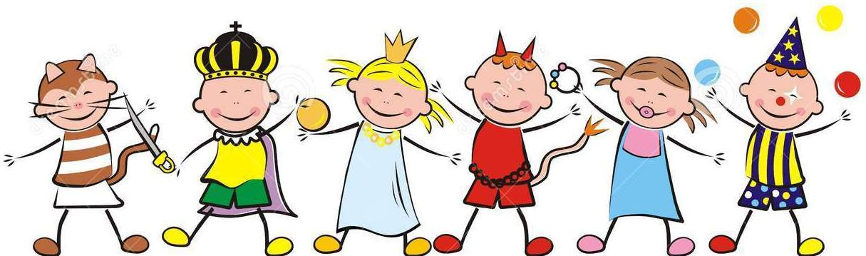

V

Dear Parents, (For Nur to Class IX)
! Greetings from Mount Litera Zee School Haridwar !
Mount Litera Zee School Haridwar invites you to the Kid's Carnival 'Radiance' on 24 Dec (Sun) 2017. Kindly show your gracious presence.
Venue : MLZS School Play Ground
Timing : 10:30 am to 3:00 pm

Dear Parents, (For Class I and II only)
This is to inform you that the school is off for class I and II on 23 Dec (Sat) 2017 as the teachers will be busy in preparation of Kid's Carnival 'Radiance' to be held on 24 Dec (Sun) 2017.

Dear Parents, (For Nursery to Sr.KG only)
This is to inform you that students participating in Master/Miss. MLZS on 24 Dec (Sun) 2017 for Kid's Carnival 'Radiance' have to reach the school by 10:30 am positively.

Dear Parents, (For Class I to IX only)
This is to inform you that students participating in Dance competition on 24 Dec (Sun) 2017 for Kid's Carnival 'Radiance' have to reach the school by 12:30 pm positively.

Dear Parents, (For Nursery to Sr.KG only)
This is to inform you that the school is closed for winter vacation from 24 Dec (Sat) 2017 to 14 Jan (Sun) 2018. The school reopens on 15 Jan (Mon) 2018. The reporting time of buses in school is 08:25 am as usual.

***********

